
DREXEL HILL
LITTLE LEAGUE

Safety Manual

Updated March 2026

For Managers, Coaches, Players, and Parents

Play Hard, Play Safe, Play Ball

TABLE OF CONTENTS
Safety Letter from the league
Little League ASAP Elements
Requirement 1 – Active Safety Officer
Requirement 2 – Distribute a Safety Manual
Requirement 3 – Post board and emergency numbers
Requirement 4 – Use Little League Volunteer Application Form and Check for Sex Abuse
Requirement 5 – Provide Fundamentals Training
Requirement 6 – Require First Aid Training
Requirement 7 – Walk Fields for Hazards Prior to Play
Requirement 8 – Complete Annual Little League Field Survey
Requirement 9 – Safety Procedures for Concessions
Requirement 10 – Inspect and Replace Equipment
Requirement 11 – Implement Accident Reporting Procedures
Requirement 12 – First Aid kits at games
Requirement 13 – Enforce Little League Rules Including Equipment

Appendix A – page 13 – Drexel Hill Little League Accident Reporting Form
Appendix B– page 16 – Drexel Hill Little League 2025 Safety Code
Appendix C– page 18 – Drexel Hill Little League 2025 Communicable Disease Procedures
Appendix D– page 19 – Umpires
Appendix E – page 20 – Facility and Field Inspection Checklist
Appendix F– page 21 – Concussion Awareness
Appendix G– page 25 – Drexel Hill Little League Background Checks
Appendix H– page 26 – First –Aid Contents
Appendix I– page 27 – Important Do’s and Don’ts

Drexel Hill L.L. Mission Statement “Safety is Everyone's Responsibility"

Drexel Hill Little League's highest priority is for the safety of our kids. Prevention is the key to reducing accidents. At Drexel Hill Little League we are committed to encouraging and providing a safe environment. In order to succeed we need your commitment to become our Safety Advocates for Drexel Hill Little League.
Drexel Hill Little League is actively participating in Little Leagues, A Safety Awareness Program (ASAP), whose mission is "to create awareness, through education and information, of the opportunities to provide a safer environment for kids and all participants of Little League Baseball."
The purpose of this manual is to provide important safety information to Drexel Hill Little League. While specifically written for Managers, and Coaches the information contained in this document can be a useful resource for all participants of Drexel Hill Little League. Please take the time to review this manual in its entirety.
We request your assistance, and guidance in making Drexel Hill League a great program. If you have any concerns, or suggestions for improvement, please contact us at dhllboard@dhllpa.com. For additional information visit our web site at www.dhllpa.com. We want to hear from you.

Thank you for your commitment to Drexel Hill Little League.

Drexel Hill Little League Board

Requirement 1 – Active Director of Safety
Drexel Hill Little League (DHLL) has an active Director of Safety – Stephanie Ripley. The Director of safety is a member of the Board of Directors page 5 of this document.
Requirement 2 – Distribute a Safety Manual
The Drexel Hill Little League Safety Manual is available on line at www.dhllpa.com.
Requirement 3 – Post board and emergency numbers
All managers and coaches shall use “911” for all on field emergencies requiring fire, police, or
Ambulance. Managers and coaches shall keep player emergency contact information with them at all times and have a working cell phone during practice and games.
Drexel Hill Little League Emergency Contact Phone List:
Emergency Police/Fire/Ambulance “911”
League President: (610) 202-4785
Director of Safety: (610)731-7578

Board Position | Board Member
League President/Treasurer | Sean Lee
Player Agent | Nicholas Hoyt
Treasurer | David Meno
Secretary | Megan Gerber
Director of Softball | Doug Wanamaker
Director of Baseball | Ryan Ripley
Directors of Player and Coaching Development | Curt Minton and Kevin Law
Director of Facilities | Vince Kirby
Director of All-Stars and Demons | Dave Hyland
Umpire-in-Chief and Rules | Pat Muldoon
Director of Safety | Stephanie Ripley
Director of Spirit Wear/Uniforms | Karla smith
President Emeritus (Trustee) | Jack McCann
Director of Hosted Tournaments | Jim Mullen and Ryan Ripley
Director of Fundraising | Matt Serra

Requirement 4 – Use Little League Volunteer Application Form and Check for Sex Abuse

DHLL uses the Little League International Sports Connect / JDP & Volunteer Application Form (online) and checks for sex abuse history as well as criminal background. DHLL requires all managers, coaches, board members, and any other person, volunteers or hired workers, who provide regular services to the league or who have repetitive access to or contact with the players or teams must fill out an application form as well as provide a government issued photo identification card for ID verification. DHLL conducts a search of the appropriate governmental entity of the nationwide sex offender registry on all volunteer applications received through Sports Connect / JDP. Anyone refusing to fill out a volunteer application is ineligible to be a league member. The league President is required to retain these confidential forms for one year of service. https://www.littleleague.org/downloads/volunteer-application/

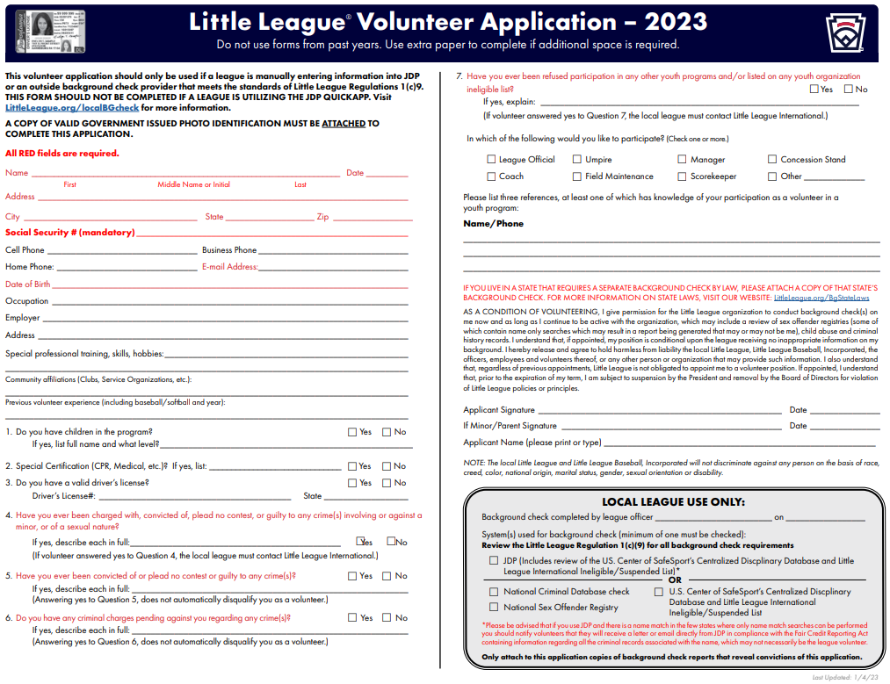

4.2- Abuse Awareness Training for adults will be a volunteer requirement

All league volunteers will be instructed to complete the annual training Little League Abuse awareness training. This course can be completed online, producing a certificate of completion that volunteers may share with the safety officer who will be overseeing the league’s background checks to verify completion of the training
Requirement 5 – Provide Fundamentals Training
5.1 Current
Drexel Hill Little League conducts coaches’ clinics on March 28nd, 2026, prior to the season. Managers and coaches will be trained on hitting, sliding, fielding and pitching fundamentals. Managers and coaches are periodically provided with many brochures and are encouraged to participate in other clinics.
5.2 Future
DHLL continuously notifies coaches of local coaches’ clinics provided by private vendors, high schools and local universities.

Requirement 6 – Require First Aid Training
Basic first aid training is covered in the Drexel Hill Little League annual coach’s meeting prior to the season starting. This meeting is scheduled for March 18th, 2026.

Requirement 7 – Walk Fields for Hazards Prior to Play
7.1 Fields
Coaches and umpires are required to walk the fields for hazards before use. Rain/Mud-Playing on muddy fields with wet equipment places the players at risk and creates ruts and holes that can be a hazard. When in doubt, reschedule the game.
7.2 Weather Conditions
Lightning - Halt play and evaluation should occur if the time between a lightning flash and the sound of thunder is less than fifteen (15) seconds. Seek shelter in a large enclosed building or fully enclosed metal vehicle. If caught in the open place feet together, squat down, and cover ears (to prevent eardrum damage). Play will be suspended for 30 mins after the last flash or thunder.
Heat - Anytime temperature is above 90 degrees Fahrenheit, or the relative humidity is above 95%, a halt for rest and fluids should occur after the 3rd inning. Have shade and adequate water available. Encourage players to drink small amounts frequently. Any player exhibiting signs of heat related illness (cramps, fatigue, light headedness, nausea, vomiting or headache), should be removed from the game, placed in the shade, and re-hydrated. If symptoms do not respond immediately, seek prompt medical aid.
Rain/Mud - Playing on muddy fields with wet equipment places the players at risk and creates ruts and holes that can be a hazard. When in doubt reschedule the game.

Sun Exposure – The league is providing a sunscreen station which is located at the snack bar
7.3 Players
Jewelry - Players are not allowed to wear jewelry, except for medic-alert bracelets or necklace.
Uniforms - Uniforms must be in good repair.
Equipment - Equipment must be in good repair
On-Deck Circle - On-deck circle is NOT allowed.
Pitcher - Pitchers warming up in an area subject to foul balls should have a spotter with helmet and glove.
7.4 Spectators
Arguing - Spectators are not allowed to argue with any call made by the umpire. It is the manager's responsibility to keep spectators within acceptable behavior limits. Coaches behavior in the dugout is expected to remain composed, its understood there will be missed calls but any coach displaying inappropriate behavior will not be tolerated and told to leave.
Foul Territory - Spectators in foul territory are to remain alert and well back from the field of play.
Benches/Dugouts - Benches and dugouts are for managers, coaches and players only. If not on the field of play, all players (except warm-up pitchers and catchers) must remain within the benches/dugout area. 4 Adults are the maximum number of people allowed in the dugout and these people are the head coach and assistants.
Young Children - Young children must be properly supervised at all times.
Pets – Pets are not permitted at Dermond Recreational Complex per the Upper Darby Township ordinance.
Requirement 8 – Complete Annual Little League Field Survey
DHLL does not own, any of fields that are used for league functions. DHLL works in conjunction with the Township of Upper Darby and the Upper Darby Parks and Recreation (UDPRD) to ensure the fields and facilities are in good working and safe condition. The annual little league field survey is completed prior to practices starting each year.

Requirement 9 – Safety Procedures for Concessions
Cooking - Use a food thermometer to check on cooking and holding temperatures of potentially hazardous foods. All potentially hazardous foods should be kept at 41º F or below (if cold) or 140º F or above (if hot). Ground beef and ground pork products should be cooked to an internal temperature of 155º F, poultry parts should be cooked to 165º F. Most food borne illnesses from temporary events can be traced back to lapses in temperature control.

Reheating - Rapidly reheat potentially hazardous foods to 165º F. Do not attempt to heat foods in crock pots, steam tables, over sterno units or other holding devices. Slow-cooking mechanisms may activate bacteria and never reach killing temperatures.

Cooling and Cold Storage - Foods that require refrigeration must be cooled to 41º F as quickly as possible and held at that temperature until ready to serve. To cool foods down quickly, use an ice water bath (60% ice to 40% water), stirring the product frequently, or place the food in shallow pans no more than 4 inches in depth and refrigerate. Pans should not be stored one atop the other and lids should be off or ajar until the food is completely cooled. Check temperature periodically to see if the food is cooling properly. Allowing hazardous food store main unrefrigerated for too long has been the number ONE cause of food borne illness.

Hand Washing - Frequent and thorough hand washing remains the first line of defense in preventing food borne disease. The use of disposable gloves can provide an additional barrier to contamination, but they are no substitute for hand washing!
Health and Hygiene - Only healthy workers should prepare and serve food. Anyone who shows symptoms of disease (cramps, nausea, fever, vomiting, diarrhea, jaundice, etc.) or who has open sores or infected cuts on the hands should not be allowed in the food concession area. Workers should wear clean outer garments and should not smoke in the concession area. The use of hair restraints is recommended to prevent hair ending up in food products.
Food Handling - Avoid hand contact with raw, ready to-eat foods and food contact surfaces. Use an acceptable dispensing utensil to serve food. Touching food with bare hands can transfer germs to food.
Dishwashing - Use disposable utensils for food service. Keep your hands away from food contact surfaces, and never reuse disposable dishware. Wash in a four-step process:
- Washing in hot soapy water;
- Rinsing in clean water;
- Chemical or heat sanitizing;
- Air drying.

Ice - Ice used to cool cans/bottles should not be used in cup beverages and should be stored separately. Use a scoop to dispense ice; never use the hands. Ice can become contaminated with bacteria and viruses and cause food borne illness

Wiping Cloths – Rinse and store your wiping cloths in a bucket of sanitizer (example: 1 gallon of water and ½ teaspoon of chlorine bleach). Change the solution every two hours. Well sanitized work surfaces prevent cross-contamination and discourage flies.

Food Storage and Cleanliness - Keep foods stored off the floor at least six inches. After your event is finished, clean the concession area and discard unusable food.

Requirement 10 – Inspect and Replace Equipment
DHLL's Equipment Manager inspects all equipment prior to distribution to the managers. Defective and/or badly worn catcher's equipment and bats are replaced. Equipment issues should be reported to the Equipment Manager.
Inspection - Inspect equipment regularly and make sure it fits properly.
Catcher - Catchers must wear catcher's helmet, mask, throat protector, shin guards, long model check protector, and protective cup at all times. Helmet must be NOCSAE approved
Pitchers Warm-Up - Catchers must wear catcher's helmet, mask, throat protector, shin guards, long model check protector, and protective cup when warming up pitchers.
Glasses - Parents should be encouraged to provide safety glasses for their children wearing glasses.
Face Guards/Cups - Parents should be encouraged to provide mouth guards and cups for their children.
Safety Bases – Are utilized for the lower divisions in Drexel Hill Little League, coaches must use safety bases which are located in equipment boxes at each field.
Bats – All bats must comply with Little League International Regulations. (USA Bats)
https://www.littleleague.org/playing-rules/bat-information/
Requirement 11 – Implement Accident Reporting Procedures
The Director of Safety will keep a record of all accident reports. See Appendix A (accident report form) on page 13 and the process of filing an incident report on page 14 of this document. Accident reports shall be submitted within 24 hours of the incident to Stephanie Ripley at sbrennan41@yahoo.com
Accident Procedure
- Administer First Aid to the level of your training. Call 911 if necessary.
- Reassure the injured party and spectators.
- Contact the injured parties’ parent or guardian. If unavailable, contact the emergency
contact listed on the registration form.
- Control the crowd.
- Talk to your team about the situation. Often players are upset and worried when a teammate is injured. They need to feel safe and understand why the injury occurred.
- Consult your “First Aid Booklet” for return to play guidelines. Any injury requiring professional medical care will need a physician’s clearance prior to returning to play. Contact your league “Safety Officer” by phone within 24 hours of the incident.
Communicable Diseases (additional information Appendix C)
- Bleeding must be stopped, open wounds covered, and the uniform changed if there is blood on it before the athlete may return to play.
- Use gloves when coming in contact with blood or body fluids. Gloves are provided in all First Aid Kits.
- Immediately wash hands with soap and other skin surfaces contaminated with blood.
- Clean blood contaminated surfaces and equipment.
- Store blood or body fluid contaminated uniforms or gear in plastic bags for thorough cleaning at home.
- Place all blood and body fluid contaminated First Aid equipment (i.e. bloody gloves, bloody dirt, etc) in a zip-lock bag. Seal the bag and throw it into a trash can. Zip-lock bags are provided in all First Aid kits.
- Managers, coaches, and volunteers with open wounds should refrain from all direct contact
until condition is resolved.
Requirement 12 – First Aid
First Aid supplies are available during games at the concession stand and additional supplies are located in the clubhouse above the concession stand. The Safety Officer is responsible for the coordination of the safety equipment. The Safety Officer is responsible for re-supplying the first aid kits when needed. The AED machine is located in the clubhouse and tested to ensure proper functioning. Also located in the clubhouse is a choking rescue device (LifeVac).
Requirement 13 – Enforce Little League Rules Including Equipment
Managers, coaches, and umpires should be thoroughly familiar with the current Little League Rule Book. The DHLL Board of Directors is responsible for enforcing the existing little league rules. The consequence of the participants in failure to follow the rules includes the following punishment:
- A letter of reprimand or admonishment;
- The offending party may be suspended for a game and/or games
- The offending party may not be allowed to participate in Drexel Hill Little League;
- The offending party’s team may be caused to forfeit a game or games;

Enforcement of little league rules is the responsibility of every participant and the board will enforce its rules if violated.

See Appendix B page 16 for Drexel Hill League Safety Code.

See Appendix D page 19 for umpire information.
Parents Role in Safety
Most of the existing Little League rules have some basis in safety. Parents can help by setting a good example for all the players. It is important to follow the rules for the safety of everyone involved. The managers and coaches are or will be trained in first aid fundamentals and common-sense safety. Please take the time to listen to the manager and coaches, learn these rules and make them common practice any time you practice baseball with your children.

Complete a Medical Release
This enables emergency medical care if parent or guardian is not in attendance, and also informs managers, coaches and medical providers of allergies or other medical problems.
No alcohol or tobacco on the field. If volunteers must smoke or chew tobacco, please do it away from the players in designated areas. If the players can see you smoke or chew, you are too close!
Please be extra cautious when entering and leaving the parking lots. Children may not always look for you, especially young future ball players.
It is important that you share any medical information that may affect your child during games and practice. If you have concerns or questions, please contact the manager or League Safety Officer. All information is considered confidential. Have your child eat a snack before practice or games; hungry ball players don’t concentrate well. Routinely, check your child’s equipment for safety concerns.

Arrive to practice and games early to allow for proper warm ups
Help out at practices. The more adults we have watching out for our players, the better our chance to avoid accidents. Volunteering in both District and League activities will make your child’s experience even better.

Golden Rules

No one holds a bat! Many players bring their own bats to practice and games. They should remain in their bags, in the dugout or on the ground in front of them until they are needed.
No one holds a bat except when going to the plate.

The manager or coach will never leave a player alone at the field. It is very important that parents are on time to pick up the children on time. It is recommended that parents remain at the field if possible. If this is not possible, please contact the coach or manager prior to the event.

Drexel Hill Little League Accident Reporting Form
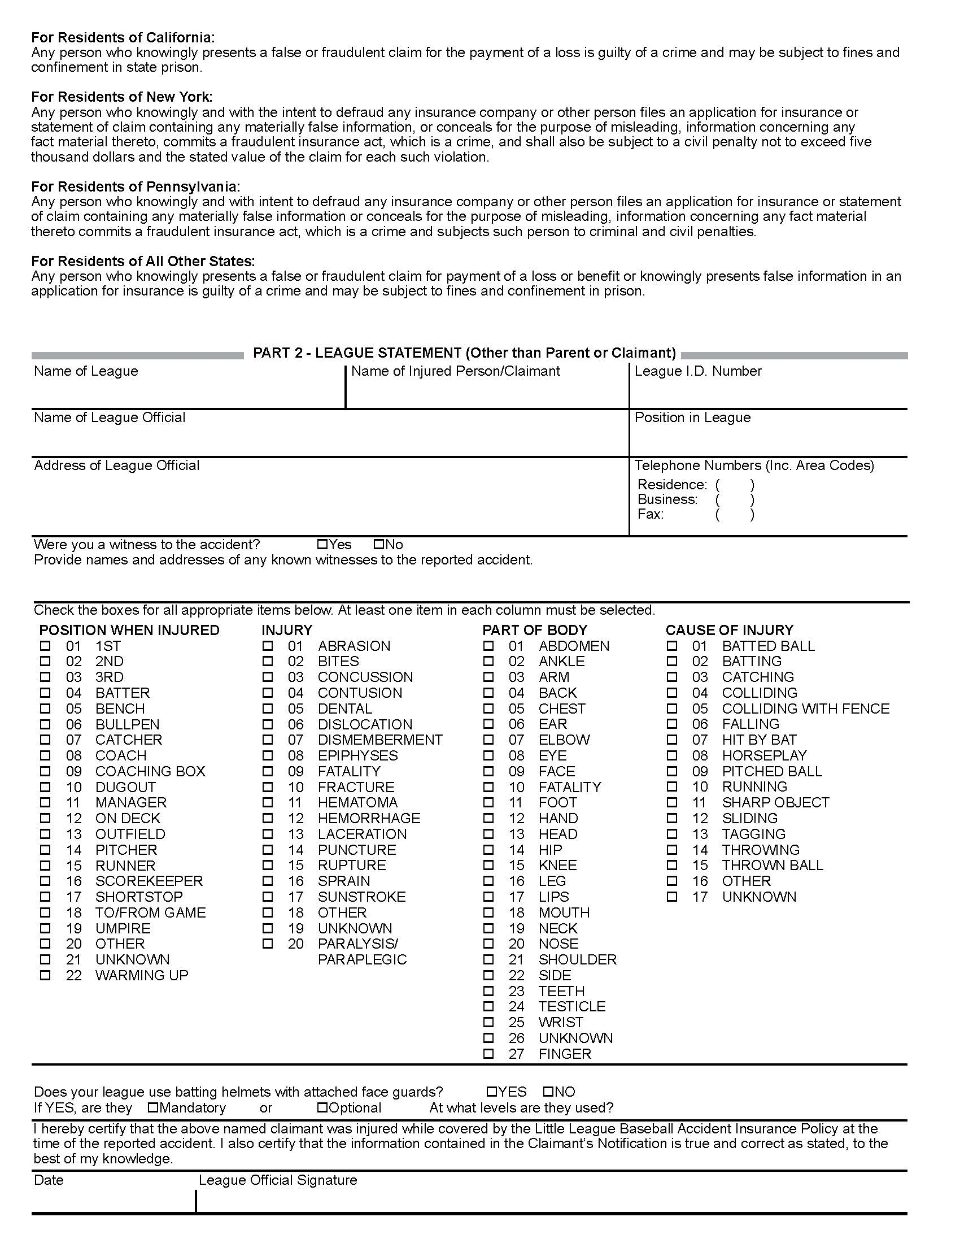
Little League Baseball & Softball
CLAIM FORM INSTRUCTIONS
WARNING — It is important that parents/guardians and players note that: Protective
equipment cannot prevent all injuries a player might receive while participating in baseball/softball.
To expedite league personnel’s reporting of injuries, we have prepared guidelines to use as a checklist in
completing reports. It will save time -- and speed your payment of claims.
The NUFI Accident Master Policy acquired through Little League contains an “Excess Coverage Provision”
whereby all personal and/or group insurance shall be used first.
To help explain insurance coverage to parents/guardians refer to “What Parents Should Know” on the
internet that should be reproduced on your league’s letterhead and distributed to parents/guardians of
all participants at registration time.
If injuries occur, initially it is necessary to determine whether claimant’s parents/guardians or the
claimant has other insurance such as group, employer, Blue Cross and Blue Shield, etc., which pays benefits. (This information should be obtained at the time of registration prior to tryouts.) If such coverage is provided, the claim must be filed first with the primary company under which the parent/guardian or claimant is insured.
When filing a claim, all medical costs should be fully itemized and forwarded to Headquarters. If no other insurance is in effect, a letter from the parent’s/guardian’s or claimant’s employer explaining the lack of group or employer insurance should accompany the claim form.
The NUFI Accident Policy is acquired by leagues, not parents, and provides comprehensive coverage at an affordable cost. Accident coverage is underwritten by National Union Fire Insurance Company of Pittsburgh, Pa. This is a brief description of the coverage available under the policy. The policy will contain limitations, exclusions, and termination provisions.
With your league’s cooperation, insurance rates have increased only three times since 1965. This rate stability would not have been possible without your help in stressing safety programs at the local level. The ASAP manual, League Safety Officer Program Kit, is recommended for use by your Safety Officer. In 2000 the State of Virginia was the first state to have its accident insurance rates reduced by high participation in ASAP and reduction in injuries. In 2002, seven more states have had their accident insurance rates reduced, as well. They are Alaska, California, Delaware, Idaho, Montana, Washington, Wisconsin.
TREATMENT OF DENTAL INJURIES
Deferred Dental Treatment for claims or injuries occurring in 2023 and beyond: If the insured incurs injury to sound, natural teeth and necessary treatment requires that dental treatment for that injury must be postponed to a date more than 52 weeks after the date of the injury due to, but not limited to, the physiological changes occurring to an insured who is a growing child, we will pay the lesser of the maximum benefit of $1,500.00 or the reasonable expense incurred for the deferred dental treatment. Reasonable expenses incurred for deferred dental treatment are only covered if they are incurred on or before the insured’s 23rd birthday. Reasonable Expenses incurred for deferred root canal therapy are only covered if they are incurred within 104 weeks after the date the Injury occurs.

CHECKLIST FOR PREPARING CLAIM FORM
- Print or type all information.
- Complete all portions of the claim form before mailing to our office.
- Be sure to include league name and league ID number.

PART I - CLAIMANT, OR PARENT(S)/GUARDIAN(S), IF CLAIMANT IS A MINOR
- The adult claimant or parent(s)/guardians(s) must sign this section, if the claimant is a minor.
- Give the name and address of the injured person, along with the name and address of the parent(s)/guardian(s), if claimant is a minor.
- Fill out all sections, including check marks in the appropriate boxes for all categories. Do not leave any section blank. This will cause a delay in processing your claim and a copy of the claim form will be returned to you for completion.
- It is mandatory to forward information on other insurance. Without that information there will be a delay in processing your claim. If no insurance, written verification from each parent/spouse employer must be submitted.
- Be certain all necessary papers are attached to the claim form. (See instruction 3.) Only itemized bills are acceptable.
- On dental claims, it is necessary to submit charges to the major medical and dental insurance company of the claimant, or parent(s)/guardian(s) if claimant is a minor. “Accident-related treatment to whole, sound, natural teeth as a direct and independent result of an accident” must be stated on the form and bills. Please forward a copy of the insurance company’s response to Little League Headquarters. Include the claimant’s name, league ID, and year of the injury on the form.

PART II -LEAGUE STATEMENT
- This section must be filled out, signed and dated by the league official.
- Fill out all sections, including check marks in the appropriate boxes for all categories. Do not leave any section blank. This will cause a delay in processing your claim and a copy of the claim form will be returned to you for completion.

IMPORTANT: Notification of a claim should be filed with Little League International within 20 days of the incident for the current season.

Drexel Hill Little League Safety Code

- Arrangements should be made in advance of all games and practices for emergency medical services.
- Managers, Coaches, and umpires should have some training in First-Aid. First-Aid kits should be available at the field and must be inspected weekly. After each use contact the Safety Officer for re-supply.
- No games or practices should be held when weather or field conditions are not good particularly when lighting is inadequate. If the surrounding street lights are on, it is probably too dark to continue playing, and the game should be called.
- Play area should be inspected frequently for holes, damage, stones, glass, and other foreign objects.
- Dugouts and bat racks should be positioned behind screens.
- Only players, Managers, Coaches, and umpires are permitted on the playing field during play and practice sessions.
- Managers or coaches must not warm up a pitcher at home plate or in the bull pen or elsewhere at any time. They may, however stand to observe a pitcher during warm-up in bull pen.
- Responsibility for keeping bats and loose equipment off the field of play should be that of a regular player assigned for this purpose.
- Procedure should be established for retrieving foul balls batted out of the playing area.
- During practice sessions and games, all players should be alert and watching the batter on each pitch.
- During warm-up drills, players should be spaced so that no one is endangered by wild throws of missed catches.
- Equipment should be inspected regularly. Make sure it fits properly.
- Batters must wear protective NOCSAE helmets during batting practice, as well as during games.
- Catchers must wear a catcher’s helmet (with face mask and throat guard – NOCSAE approved), chest protector, and shin guards. Male catchers must wear long model chest protector, protective supporter, and cup at all times.
- All male players must wear athletic supporters. We strongly recommend that all male players wear cups as well.
- Except when a runner is returning to a base, headfirst slides are not permitted.
- During sliding practice, bases should not be strapped down.
- At no time should “horse play” be permitted on the playing field.
- Parents of players who wear glasses should be encouraged to provide “safety glasses” with an elastic retaining strap.
- Players must not wear watches, rings, pins, jewelry, or other metallic items.
- Catchers must wear full gear and a protective cup in warming up pitchers. This applies during practice, between innings and in the bullpen.
- Batting/catcher’s helmets should not be painted unless approved by the manufacturer.
- Regulations prohibit on-deck batters. This means no player should handle a bat, even while in an enclosure, until it is his/her time at bat.
- Players who are ejected, ill, or injured should remain under supervision until released to the parent or guardian.
- No metal pitching toe should be worn.
- Baseball shoes with rubber cleats molded to the sole, tennis, or gym shoes are authorized.
- Do not allow players to throw bats or helmets.
- Do not allow players to visit the restroom alone, have the child’s parent or volunteer escort the player to and from the restroom and back to the field of play.
- Report all injuries to the Drexel Hill Little League Director of Safety. safety@dhllpa.com
- Please do not visit the dugout during games. If you need your ballplayer, contact the coach.

Drexel Hill Little League Communicable Disease Procedures
These procedures, also printed in each of the Official Regulations and Playing Rules, should be understood and followed by all managers, coaches, and umpires. While risk of one athlete infecting another with HIV/AIDS during competition is close to non-existent, there is a remote risk that other blood borne infectious diseases can be transmitted. For example, Hepatitis B can be present in blood, as well as in other body fluids. Procedures for reducing the potential for transmission of these infectious agents should include, but not be limited to, the following:
- The bleeding must be stopped, the open wound covered, and if there is an excessive amount of blood on the uniform, it must be changed before the athlete may participate.
- Routine use of gloves or other precautions to prevent skin and mucous-membrane exposure when contact with blood or other body fluids is anticipated.
- Immediately wash hands and other skin surfaces if contaminated (in contact) with blood or other body fluids. Wash hands immediately after removing gloves.
- Clean all blood contaminated surfaces and equipment with an appropriate disinfectant before competition resumes.
- Practice proper disposal procedures to prevent injuries caused by needles, scalpels, and other sharp instruments or devices
- Although saliva has not been implicated in HIV transmission, to minimize the need for emergency mouth-to-mouth resuscitation, mouthpieces, resuscitation bags, or other ventilation devices should be available for use.
- Athletic trainers/coaches with bleeding or oozing skin conditions should refrain from all direct athletic care until the condition resolves.
- Contaminated towels should be properly disposed of or disinfected.
- Follow acceptable guidelines in the immediate control of bleeding and when handling bloody dressings, mouth-guards, and other articles containing body fluids.

Umpires
In our league, the umpires are furnished from a pool of league volunteers and paid umpires. As Little League rules dictate, they are in complete control of what happens on the field. Umpires play an important role in safety. Umpire training is essential to the safety of the players, managers & coaches, spectators, and other umpires. A Drexel Hill League Umpires clinic will be held during the preseason to teach the proper skills to anyone who is interested in umpiring.
The following is a list of topics the clinic will cover.
- Umpires must be fair, impartial, and consistent. All trained Umpires will go away from training with a good understanding of the rules.
- Proper positioning (and rotation) in the field to avoid obstructing play or getting injured.
- Basic rules of baseball, and interpretations of commonly misunderstood rules.
- Safety violations.
- Pre-game procedures.
- Walk the field for foreign objects, holes and any hazards that might cause injury. Ensure installation of disengage-able bases.
- Inspect equipment for any safety violations prior to the start of any game.

Facility and Field Inspection Checklist
Facility Name____________________ Inspector _____________________ Date _______
Daily Routine before Practice:
Mow as needed
Remove tarps
Water skinned areas and baselines
Install the bases
Erect safety screens for pitcher, first base and second base
Place the batting cage at home plate
Daily Routine after Practice and Games:
Remove the bases and cover the base anchor sleeves
Drag the skinned areas and baselines
Rake loose dirt off grass along base paths, mound circle, and infield edge
Rebuild the mound and home plate area and cover areas with tarps
Rebuild the bull pen mound and home plate area
Replace and tamp any loose divots in turf areas
Dispose of trash in and around field and bleacher areas
Day of Game Routine:
Remove tarps
Mow the grass
Scarify the skinned areas with a spiker
Drag the skinned areas smooth
Water the infield area and mound (rebuild mound / batter box as needed)
Sweep and clean dugouts
Set the chalk lines and mark officially – mark on fair side of stringer
Paint or wash bases, pitching plate and home plate
Prepare the bullpens
Check the operation of the field lights
Check the operation of the scoreboard
Prepare the press box and operation of the public address system
Check the operation of the electrical equipment in the concession stand
Clean and prepare the locker rooms and umpire rooms
Dispose of trash found in and around field and bleacher areas

Special Notes/Hazards: Signature:
Concussion Awareness
THE FACTS:
- A concussion is a serious brain injury.
- All concussions are serious.
- Concussions can occur without loss of consciousness.
- Concussions can occur in any sport.
- Recognition and proper management of concussions when they first occur can help prevent further injury or even death.

WHAT IS A CONCUSSION?
A concussion is an injury that changes how the cells in the brain normally work. A concussion is caused by a blow to the head or body that causes the brain to move rapidly inside the skull. Even a “ding,” “getting your bell rung,” or what seems to be a mild bump or blow to the head can be serious. Concussions can also result from a fall or from players colliding with each other or with obstacles, such as a goalpost, even if they do not directly hit their head.
The potential for concussions is greatest in athletic environments where collisions are common. Concussions can occur, however, in any organized or unorganized sport or recreational activity. As many as 3.8 million sports and recreation-related concussions occur in the United States each year.
RECOGNIZING A POSSIBLE CONCUSSION:
To help recognize a concussion, you should watch for the following two things among your athletes:
- A forceful blow to the head or body that results in rapid movement of the head. -and
- Any change in the athlete’s behavior, thinking, or physical functioning. (See the signs and symptoms of concussion.)

SIGNS AND SYMPTOMS:
Signs observed by coaching staff:
- Appears dazed or stunned
- Is confused about assignment or position
- Forgets sports plays
- Is unsure of game, score, or opponent
- Moves clumsily
- Answers questions slowly
- Loses consciousness (even briefly)
- Shows behavior or personality changes
- Can’t recall events prior to hit or fall
- Can’t recall events after hit or fall
Symptoms Reported By Athlete:
- Headache or “pressure” in head
- Nausea or vomiting
- Balance problems or dizziness
- Double or blurry vision
- Sensitivity to light
- Sensitivity to noise
- Feeling sluggish, hazy, foggy, or groggy
- Concentration or memory problems
- Confusion
- Does not “feel right”

Athletes who experience any of these signs or symptoms after a bump or blow to the head should be kept from play until given permission to return to play by a health care professional (see Licensed Health Care Provided list below) with experience in evaluating for concussions. Signs and symptoms of concussion can last from several minutes to days, weeks, months, or even longer in some cases.
Remember, you can’t see a concussion and some athletes may not experience and/or report
symptoms until hours or days after the injury. If you have any suspicion that your athlete has a concussion, you should keep the athlete out of the game or practice.
PREVENTION AND PREPARATION:
As a coach, you can play a key role in preventing concussions and responding to them properly when they occur. Here are some steps you can take to ensure the best outcome for your athletes and the team:
- Educate athletes and parents about concussion. Talk with athletes and their parents about the dangers and potential long-term consequences of concussion. Explain your concerns about concussion and your expectations of safe play to athletes, parents, and assistant coaches. Pass out the concussion fact sheet for athletes and for parents at the beginning of the season and again if a concussion occurs.
- Insist that safety comes first.
- Teach athletes safe playing techniques and encourage them to follow the rules of play.
- Encourage athletes to practice good sportsmanship at all times.
- Make sure athletes wear the right protective equipment for their activity (such as shin guards). Protective equipment should fit properly, be well maintained, and be worn consistently and correctly.
- Review the athlete fact sheet with our team to help them recognize the signs and symptoms of
a concussion.
- Teach athletes and parents that it’s not smart to play with a concussion.
- Sometimes players and parents wrongly believe that it shows strength and courage to play
injured. Discourage others from pressuring injured athletes to play. Don’t let athletes persuade you that they’re “just fine” after they have sustained any bump or blow to the head. Ask if players have ever had a concussion.
- Prevent long-term problems. A repeat concussion that occurs before the brain recovers from the first—usually within a short period of time (hours, days, or weeks)—can slow recovery or increase the likelihood of having long-term problems. In rare cases, repeat concussions can result in brain swelling, permanent brain damage, and even death. This more serious condition is called second impact syndrome. Keep athletes with known or suspected concussion from play until they have been evaluated and given permission to return to play by a health care professional with experience in evaluating for concussion.
Remind your athletes: “It’s better to miss one game than the whole season.”

ACTION PLAN:
WHAT SHOULD A COACH DO WHEN A CONCUSSION IS SUSPECTED?
- Remove the athlete from play. Look for the signs and symptoms of a concussion if your athlete has experienced a bump or blow to the head. Athletes who experience signs of symptoms of concussion should not be allowed to return to play. When in doubt, keep the athlete out of play.
- Ensure that the athlete is evaluated right away by an appropriate health care professional. Do not try to judge the severity of the injury yourself. Health care professionals have a number of methods that they can use to assess the severity of concussions. As a coach, recording the following information can help health care professionals in assessing the athlete after the injury:
    - Cause of the injury and force of the hit or blow to the head
    - Any loss of consciousness (passed out/knocked out) and if so, for how
    - Any memory loss immediately following the injury
    - Any seizures immediately following the injury
    - Number of previous concussions (if any)
- Inform the athlete’s parents or guardians about the possible concussion and give them the fact sheet on concussions. Make sure they know that the athlete should be seen by a health care professional experienced in evaluating for concussion.
- Allow the athlete to return to play only with permission from a health care professional with experience in evaluating for concussions. A repeat concussion that occurs before the brain recovers from the first can slow recovery or increase the likelihood of having long-term problems. Prevent common long-term problems and the rare second impact syndrome by delaying the athlete’s return to the activity until the player receives appropriate medical evaluation and approval for return to play.
Licensed Health Care Providers
What licensed health care providers are trained in the evaluation and treatment of concussions/brain injuries and authorized to allow the athlete to return to play?
- Medical Doctors (MD)
- Doctor of Osteopathy (DO)
- Advanced Registered Nurse Practitioner (ARNP)
- Physicians Assistant (PA)
- Licensed Certified Athletic Trainers (ATC)

Any athlete even suspected of suffering a concussion should be removed from the game or practice immediately. No athlete may return to activity after an apparent head injury or concussion, regardless of how mild it seems or how quickly symptoms clear, without medical clearance. Close observation of the athlete should continue for several hours.
For current and up-to-date information on concussions you can go to:
http://www.cdc.gov/ConcussionInYouthSports/

As a condition of managing or coaching I have read the manager and coaches training information and will follow with practices on Concussions and Head Injuries, including educating my parents and players. I will also comply with all my league’s policies regarding Concussions and Head Injuries. I will sit a player out when in doubt and not allow that player to return to practice or a game until cleared by professional medical personnel.

Manager/Coach Name Printed: ____________________________

Manager/Coach Signature: ________________________________

Date: _____________

Drexel Hill Little League Background Check
Background
In accordance with Little League Baseball, Drexel Hill will conduct Background Checks for registered sex offenders on all adult volunteers for our 2023 season and beyond. No continued contact with the players will be allowed prior to the Background Check. The Little League Child Protection Program has been in place since 1997 with optional background checks in place. In 2005, background checks were mandatory for all programs nationwide and will be required annually.
Who will require a background check?
Drexel Hill will conduct background checks for Board Members, managers, coaches, assistant coaches and any other adult who will have regular or repetitive contact with our players.
Who will conduct background checks?
The Director of Safety will conduct the background checks through Sports Connect / JDP. In addition, the league will retain these records.
How will the background checks be conducted?
All Board Members, managers, coaches, assistant coaches and other adult volunteers will be required to complete a current Volunteer Application Form. Failure to submit this form will result in the individual being banned from participating in Drexel Hill Little League activities. Managers and coaches will not be able to hold practices or have any other contact with players until all of the coaching staff has completed the background check through Sports Connect / JDP, and have been cleared as not being a registered sex offender.
How will a volunteer be notified if their background check makes them ineligible to participate in Drexel Hill Little League?
The league president and Director of Safety will notify any adult volunteers who fail the background check of their ineligibility to be a member of Drexel Hill Little League.
Where can I get more information?
Any member of the Drexel Hill Board of Directors can provide additional information. Also, a wealth of information concerning the Child Protection Program and background checks can be found at www.littleleague.org along with contacting Pennsylvania State Police for their sex offenders list. Further information may be obtained at:
www.littleleague.org/common/childprotect/index.asp

First Aid Kit Contents
- 40 Plastic Bandages 3/4" x 3
- 8 Plastic Bandages 2" x 4.5"
- 6 Gauze Pads 4" x 4"
- 1 Roll Gauze 2"
- 1 Roll Gauze 4"
- 1 Elastic Bandage 3" x 5yds.
- 20 Antiseptic Wipes
- 6 Sting Relief Wipes
- 1 Tape 1/2" x 5 yds.
- 1 Tape 1" x 5 yds.
- Cold Packs
- 1 Scissors
- Gloves
- 10 Triple Antibiotic Ointment Packettes

Some Important Do’s and Don’ts
Do’s:

- Make arrangements to have a cellular phone available when your game or practice is at a facility that does not have any public phones
- Have your players’ “Medical Clearance Forms” with you at all games and practices
- Carry your first-aid kit to all games and practices
- Reassure and aid children who are injured, frightened, or lost
- Provide, or assist in obtaining, medical attention for those who require it
- Know your limitations
- Assist those that require medical attention – and when administering aid remember to
  - LOOK for signs of injury (Blood, Black and Blue, deformity of joint etc)
  - LISTEN to the injured describe what happened and what hurts if conscious
  - Before questioning, you may have to calm and soothe an excited child
  - FEEL gently and carefully around the injured area for swelling, or grating of broken bone
Don’ts:

- Administer any medications. Only the parent of the child should administer medications
- Provide any food or beverages (other than water)
- Hesitate in giving aid when needed
- Be afraid to ask for help if you’re not sure of the proper procedures (i.e, CPR, etc.)
- Transport injured individuals except in extreme emergencies
- Leave an unattended child at a practice, game
- Allow players to visit the restroom alone, have the child’s parent or volunteer escort the player to and from the restroom and back to the field of play
- Hesitate to report any present or potential safety hazard to the Safety Officer immediately.

